**GPA CIE 2**

**Neeti Kurulkar**

**BE A Roll No: 31040**

**Q.1.**

**#include <stdio.h>**

**#include <cuda_runtime.h>**

**// Macro for error checking**

**#define cudaCheckError(ans) { gpuAssert((ans), __FILE__, __LINE__); }**

**inline void gpuAssert(cudaError_t code, const char *file, int line, bool abort=true)**

**{**

**if (code != cudaSuccess)**

**{**

**fprintf(stderr,"GPUassert: %s %s %d\n", cudaGetErrorString(code), file, line);**

**if (abort) exit(code);**

**}**

**}**

**// Kernel: each thread adds one element**

**__global__ void vectorAdd(int *A, int *B, int *C, int N) {**

**int idx = blockDim.x * blockIdx.x + threadIdx.x;**

**if (idx < N) {**

**C[idx] = A[idx] + B[idx];**

**}**

**}**

**int main() {**

**int N = 10;**

**int size = N * sizeof(int);**

**int h_A[N], h_B[N], h_C[N];**

**for (int i = 0; i < N; i++) {**

**h_A[i] = i;**

**h_B[i] = i * 2;**

**}**

**int *d_A, *d_B, *d_C;**

**cudaCheckError(cudaMalloc((void**)&d_A, size));**

**cudaCheckError(cudaMalloc((void**)&d_B, size));**

**cudaCheckError(cudaMalloc((void**)&d_C, size));**

**cudaCheckError(cudaMemcpy(d_A, h_A, size, cudaMemcpyHostToDevice));**

**cudaCheckError(cudaMemcpy(d_B, h_B, size, cudaMemcpyHostToDevice));**

**int threadsPerBlock = 256;**

**int blocksPerGrid = (N + threadsPerBlock - 1) / threadsPerBlock;**

**vectorAdd<<<blocksPerGrid, threadsPerBlock>>>(d_A, d_B, d_C, N);**

**cudaCheckError(cudaGetLastError()); // check launch**

**cudaCheckError(cudaDeviceSynchronize()); // check runtime**

**cudaCheckError(cudaMemcpy(h_C, d_C, size, cudaMemcpyDeviceToHost));**

**printf("Result:\n");**

**for (int i = 0; i < N; i++) {**

**printf("%d + %d = %d\n", h_A[i], h_B[i], h_C[i]);**

**}**

**cudaFree(d_A); cudaFree(d_B); cudaFree(d_C);**

**return 0;**

**}**

**Output:**



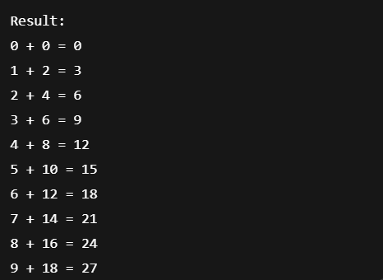

**Q.2.**

**#include <stdio.h>**

**#include <CL/cl.h>**

**const char *kernelSource =**

**"__kernel void printNameDay() { \n"**

**" int id = get_global_id(0); \n"**

**" printf(\"Global ID %d: Neeti - Tuesday\\n\", id); \n"**

**"} \n";**

**int main() {**

**cl_platform_id platform;**

**cl_device_id device;**

**cl_context context;**

**cl_command_queue queue;**

**cl_program program;**

**cl_kernel kernel;**

**// 1. Get platform and device**

**clGetPlatformIDs(1, &platform, NULL);**

**clGetDeviceIDs(platform, CL_DEVICE_TYPE_ALL, 1, &device, NULL);**

**// 2. Create context and command queue**

**context = clCreateContext(0, 1, &device, NULL, NULL, NULL);**

**queue = clCreateCommandQueue(context, device, 0, NULL);**

**// 3. Build program**

**program = clCreateProgramWithSource(context, 1, &kernelSource, NULL, NULL);**

**clBuildProgram(program, 0, NULL, NULL, NULL, NULL);**

**// 4. Create kernel**

**kernel = clCreateKernel(program, "printNameDay", NULL);**

**// 5. Run kernel (5 work-items)**

**size_t globalSize = 5;**

**clEnqueueNDRangeKernel(queue, kernel, 1, NULL, &globalSize, NULL, 0, NULL, NULL);**

**clFinish(queue);**

**// 6. Cleanup**

**clReleaseKernel(kernel);**

**clReleaseProgram(program);**

**clReleaseCommandQueue(queue);**

**clReleaseContext(context);**

**return 0;**

**}**

**Output:**

